  - Questions
Q1.
Discuss what a small business owner should consider when deciding upon the location for their business.
(6)
.............................................................................................................................................
.............................................................................................................................................
.............................................................................................................................................
.............................................................................................................................................
.............................................................................................................................................
.............................................................................................................................................
.............................................................................................................................................
.............................................................................................................................................
.............................................................................................................................................
.............................................................................................................................................
.............................................................................................................................................
.............................................................................................................................................

(Total for question = 6 marks)

Q2.
Read the following extract carefully and then answer the question.
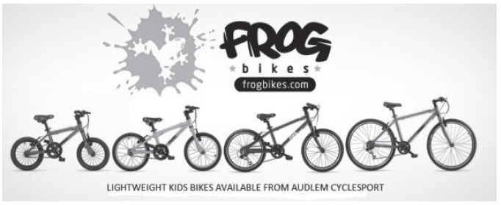
In 2012 Jerry and Shelley Lawson started a new business – Frog Bikes. The aim was to produce lightweight and affordable children's bikes. The company's bikes were designed for children using the latest technology. The bikes are produced in a Chinese factory and sold in the UK and other countries.
The business quickly became successful. By 2016 its bikes were sold in over 700 shops in the UK. It faces competitors such as JE James which sell similar bikes in the UK.
Frog Bikes uses social media to promote its bikes. Figure 2 shows a competition run on the Frog Bikes Twitter account. To enter the competition people needed to follow the business on Twitter.
As a manufacturer and retailer, Frog Bikes has to comply with a large amount of legislation. All bikes meet ISO (International Standards Office) standards. This ensures they are safe for children. Rules include the need for all bikes to be fitted with a chain guard, and for handlebars to be safety checked.
In 2016 Jerry and Shelley decided to increase production to meet the growing demand. They considered expanding the company's Chinese factory, or building a new factory in the UK.
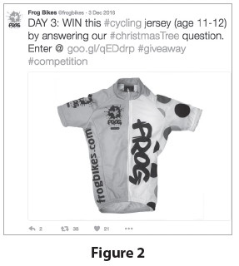
(Source: adapted from http://startups.co.uk/startups-100/2016/8-frog-bikes/)
Frog Bikes is considering two options to produce more bikes:
Option 1: Build a new factory in the UK.
Option 2: Expand production at the existing Chinese factory.
Justify which one of these two options Frog Bikes should choose.
.............................................................................................................................................
.............................................................................................................................................
.............................................................................................................................................
.............................................................................................................................................
.............................................................................................................................................
.............................................................................................................................................
.............................................................................................................................................
.............................................................................................................................................
.............................................................................................................................................
.............................................................................................................................................
.............................................................................................................................................
.............................................................................................................................................
.............................................................................................................................................
.............................................................................................................................................
.............................................................................................................................................
.............................................................................................................................................
.............................................................................................................................................
.............................................................................................................................................

(Total for question = 9 marks)

Q3.
Explain one reason why an entrepreneur would produce a business plan.
(3)
.............................................................................................................................................
.............................................................................................................................................
.............................................................................................................................................
.............................................................................................................................................
.............................................................................................................................................
.............................................................................................................................................

(Total for question = 3 marks)

Q4.
Look at Figures 1 and 2, read the extract carefully, then answer the question.
Outline one method of promotion that would be appropriate for Meringue.
(2)
.............................................................................................................................................
.............................................................................................................................................
.............................................................................................................................................
.............................................................................................................................................

(Total for question = 2 marks)

Q5.
Read the following extract carefully and then answer the question.
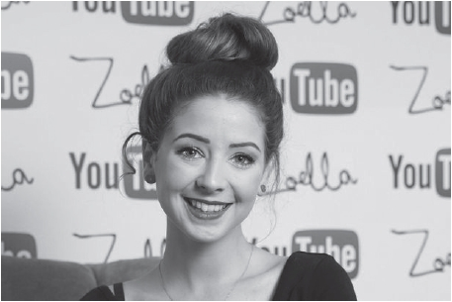
Zoe Sugg, known to her fans as Zoella, is an entrepreneur and a star of YouTube. She has enjoyed success with her fashion and lifestyle vlog (video log) and has become a celebrity as well as an entrepreneur. After starting her lifestyle blog, 'Zoella', in 2009, she soon had thousands of followers. Zoe extended the blog to a YouTube channel and by 2015 had 7.5 million subscribers.
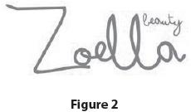
In September 2014 Zoe launched her own brand bath and beauty range, called Zoella Beauty. The brand logo is shown in Figure 2. Zoella Beauty products are stocked by major retailers, including Superdrug and Boots. The business also uses e-commerce to sell its product range.
In 2014 Zoella Beauty earned revenue of £400 000. However, the competitive environment for beauty products aimed at younger females is becoming more crowded. Rivals include retailers such as Lush.
(Source: adapted from http://startups.co.uk/young-entrepreneurs-zoe-sugg-zoella/)
Zoella Beauty is considering two options to develop the marketing mix of its beauty product line:
Option 1: Increase promotion of the brand.
Option 2: Reduce prices to compete with rival products.
Justify which one of these two options Zoella Beauty should choose.
(9)
.............................................................................................................................................
.............................................................................................................................................
.............................................................................................................................................
.............................................................................................................................................
.............................................................................................................................................
.............................................................................................................................................
.............................................................................................................................................
.............................................................................................................................................
.............................................................................................................................................
.............................................................................................................................................
.............................................................................................................................................
.............................................................................................................................................
.............................................................................................................................................
.............................................................................................................................................
.............................................................................................................................................
.............................................................................................................................................
.............................................................................................................................................
.............................................................................................................................................

(Total for question = 9 marks)

Q6.
Explain one disadvantage to a sole trader of having unlimited liability.
(3)
.............................................................................................................................................
.............................................................................................................................................
.............................................................................................................................................
.............................................................................................................................................
.............................................................................................................................................
.............................................................................................................................................

(Total for question = 3 marks)

Q7.
Look at Figures 4, 5 and 6, read the extract carefully, then answer the question.
Sally is considering whether or not to buy a franchise to start up on her own.
Justify whether or not Sally should buy a franchise.
(9)
.............................................................................................................................................
.............................................................................................................................................
.............................................................................................................................................
.............................................................................................................................................
.............................................................................................................................................
.............................................................................................................................................
.............................................................................................................................................
.............................................................................................................................................
.............................................................................................................................................
.............................................................................................................................................
.............................................................................................................................................
.............................................................................................................................................
.............................................................................................................................................
.............................................................................................................................................
.............................................................................................................................................
.............................................................................................................................................
.............................................................................................................................................
.............................................................................................................................................

(Total for question = 9 marks)

Q8.
Answer the question with a cross in a box . If you change your mind about an answer, put a line through the box and then mark your new answer with a cross .
Which one of the following statements about a franchise is correct?
Select one answer.
A A franchisee makes all their own decisions
B The franchisor pays the franchisee to set up in business
C The franchisor provides continued help and support
D Franchises pay lower Value Added Tax than sole traders

(Total for question = 1 mark)

Q9.
Answer the question with a cross in the box you think is correct . If you change your mind about an answer, put a line through the box and then mark your new answer with a cross .
Which two of the following are advantages for an entrepreneur of starting a business as a sole trader?
Select two answers.
A Limited liability means losses can be minimised
B Owner has control of decision making
C Break even level of output will be higher
D Less risky than other types of business structure
E Any profits can be kept by the owner

(Total for question = 2 marks)

Q10.
Explain one benefit to an entrepreneur of starting a business as a private limited company.
.............................................................................................................................................
.............................................................................................................................................
.............................................................................................................................................
.............................................................................................................................................
.............................................................................................................................................
.............................................................................................................................................

(Total for question = 3 marks)

Q11.
Answer the question with a cross in the box you think is correct . If you change your mind about an answer, put a line through the box and then mark your new answer with a cross .
Which one of the following is a benefit of starting a business as a franchise?
Select one answer.
A Lower variable costs
B Support from the franchisor
C Higher interest rates for borrowing
D Franchisees pay lower tax

(Total for question = 1 mark)

Q12.
Discuss the impact on a business of having limited liability.
.............................................................................................................................................
.............................................................................................................................................
.............................................................................................................................................
.............................................................................................................................................
.............................................................................................................................................
.............................................................................................................................................
.............................................................................................................................................
.............................................................................................................................................
.............................................................................................................................................
.............................................................................................................................................
.............................................................................................................................................
.............................................................................................................................................

(Total for question = 6 marks)

Mark Scheme
Q1.
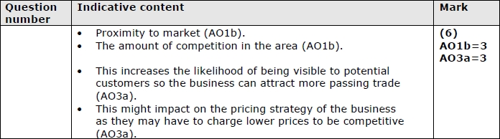
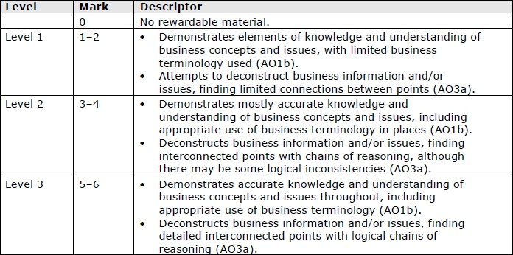

Q2.
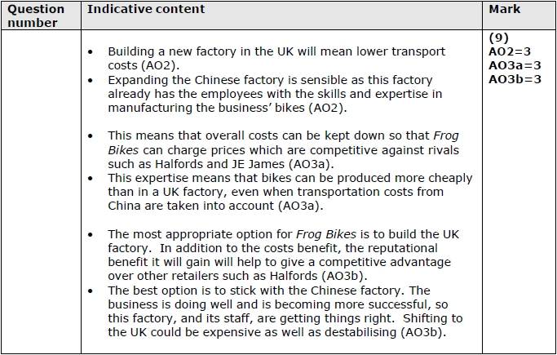
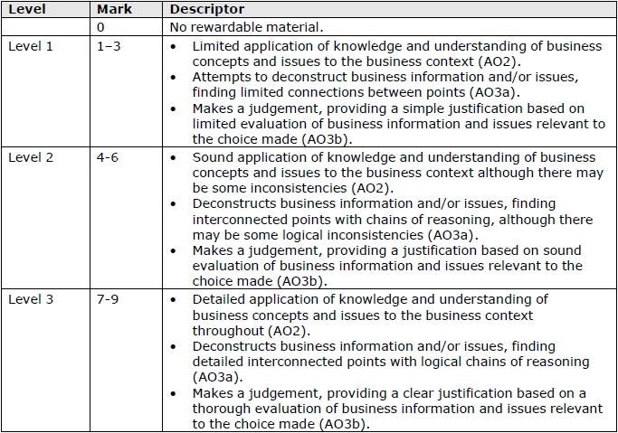

Q3.
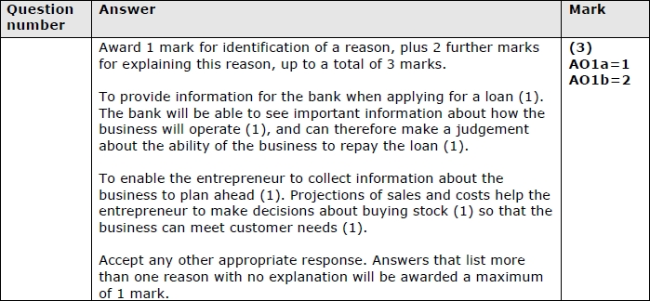

Q4.
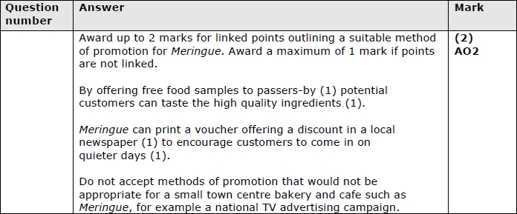

Q5.
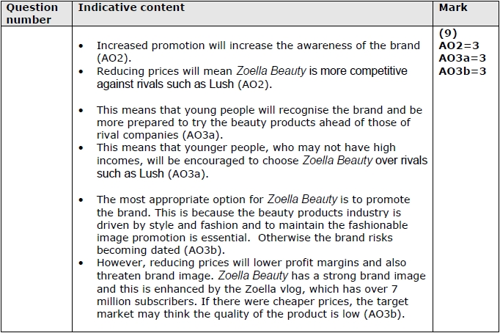
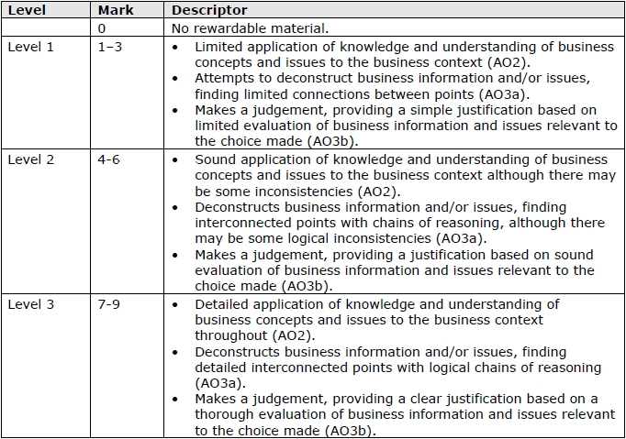

Q6.
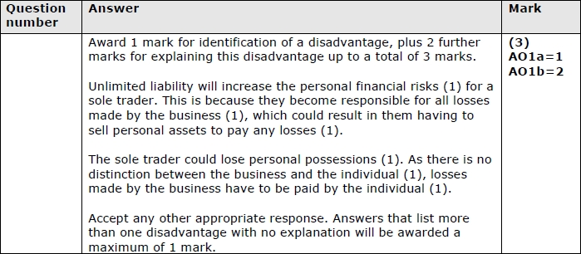

Q7.
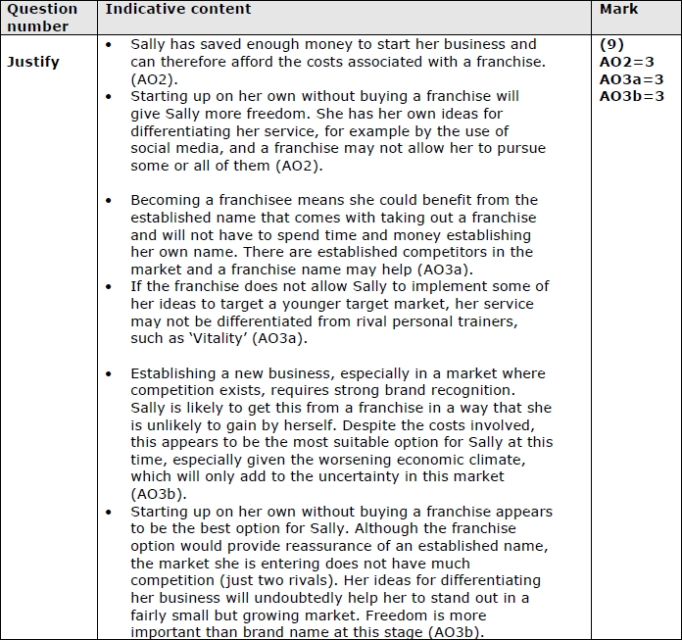
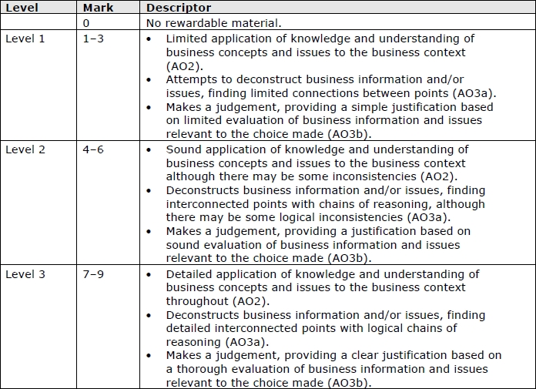

Q8.

Q9.

Q10.
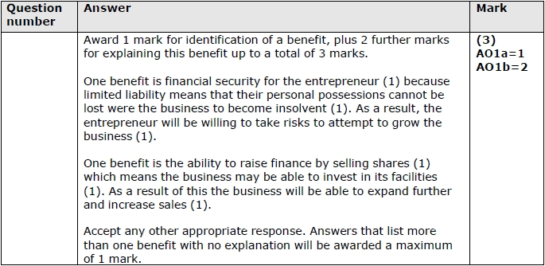

Q11.

Q12.
